The US Labor Force
K. Gwet
11/1/2021

Some Labor Force Statistics
The labor force is expected to increase by 8.9 million, from 160.7 million in 2020 to 169.6 million in 2030.
For males aged 16 or older, the labor force is projected to increase by 3.6 million from 85.2 million in 2020 to 88.8 million in 2030.
For females aged 16 or more, that increase is higher and estimated at 5.3 million from 75.5 million in 2020 to 80.8 million in 2030.
Here is the summary table of the size of the US Labor Force by gender:
gender | LF2000 | LF2010 | LF2020 | LF2030
All | 142583 | 153888 | 160744 | 169637
MEN | 76282 | 81984 | 85205 | 88794
WOMEN | 66301 | 71904 | 75539 | 80843

Including Plots
You can also embed plots in your Word document. However, the approach we recommend for creating plots requires that you transform the previous table into the long format as follows:
gender | year | laborforce
MEN | 2000 | 76282
MEN | 2010 | 81984
MEN | 2020 | 85205
MEN | 2030 | 88794
WOMEN | 2000 | 66301
WOMEN | 2010 | 71904
WOMEN | 2020 | 75539
WOMEN | 2030 | 80843
All | 2000 | 142583
All | 2010 | 153888
All | 2020 | 160744
All | 2030 | 169637
A key advantage that the long format (second table) has over the wide format (first table) is the possibility to add variables to the table other than the labor force. You could add employment or labor force participation and so on.
Creating the second table from the first in R, requires basic-level programming. But you may also decide to do it in Excel and read it in R to generate the the barplot shown below.
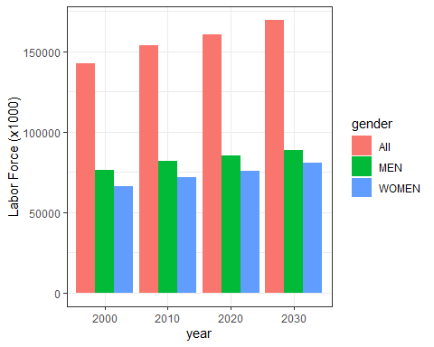
Note that you can include in the Word document, the R code that created the second table and generated the barplot.

